In the previous post, I walked you through my process of collecting all the supplies required to build a shadow scope at home for under $20. Now, I am going to use those supplies to build my very own at-home scope! You can see all the supplies I bought below, and also some miscellaneous supplies that I gathered in my home that will be helpful in the building process:

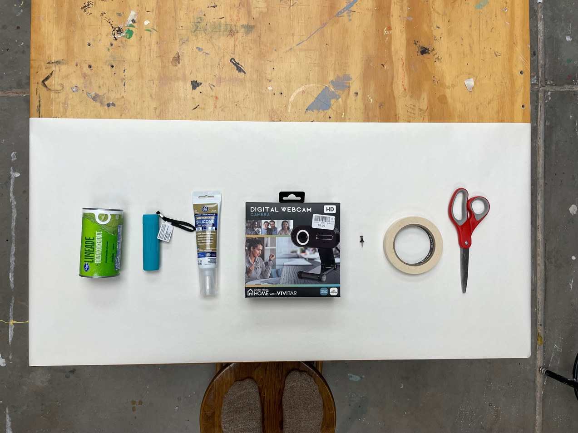

1. Limeade can
2. Flashlight
3. Silicone
4. Webcam
5. Thumbtack
6. Tape
7. Scissors

(the below items are not pictured, but still necessary for building your shadow scope):

1. Pencil
2. Small, flathead screwdriver
3. Small, Philips screwdriver

To start out, I am going to make some limeade! If you remember, I bought the limeade can to act as a cover for the camera- this creates the dark environment we need to create a shadow! But also makes a yummy treat!

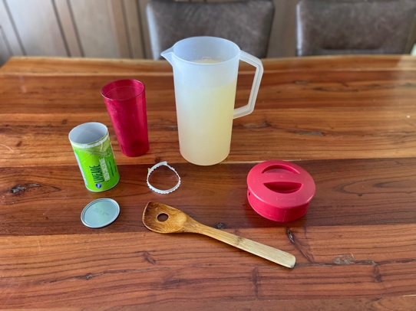

I just followed the instructions on the can to make the limeade, carefully removing and saving the lid and leaving the other aluminum end of the can intact, so I can use it later… Yum! That was a good way to start out the building project.



After that was taken care of, I started to disassemble the camera.

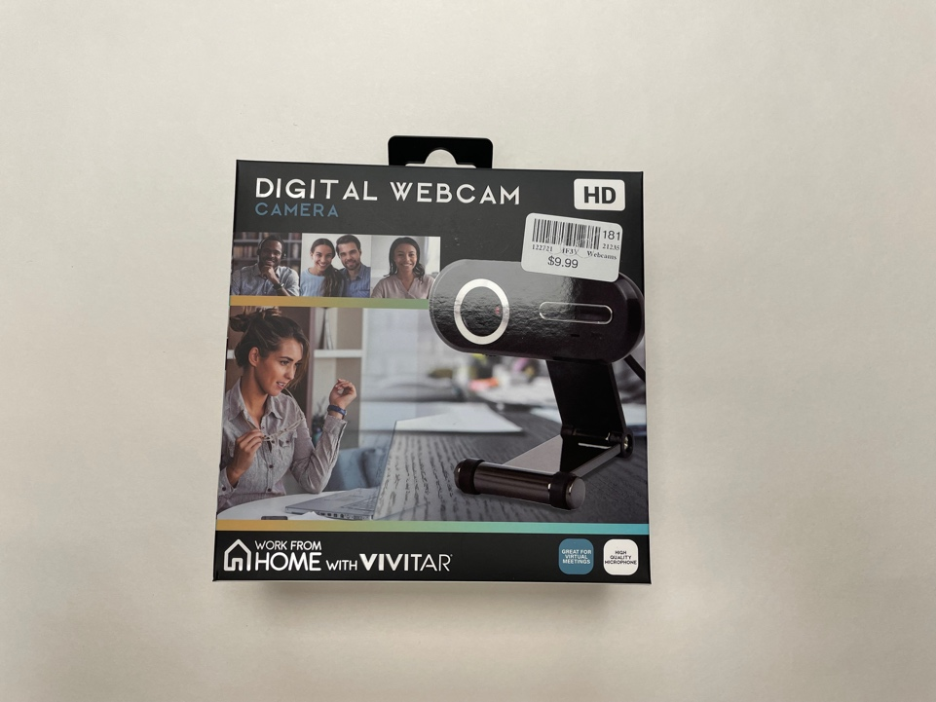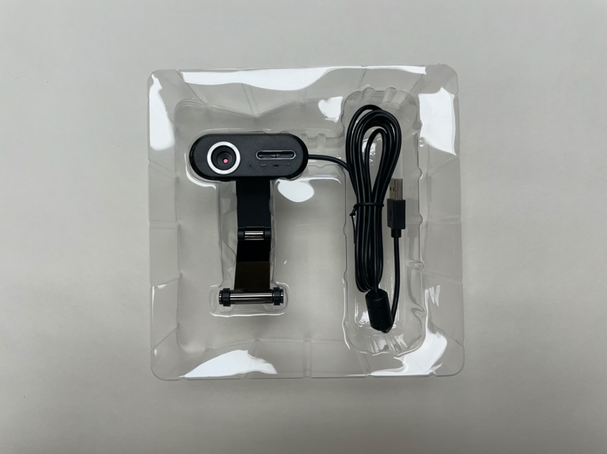

I began by using a small, flathead screwdriver to help me pry the front face off of the camera. It came off pretty easily and ended up giving me this result:

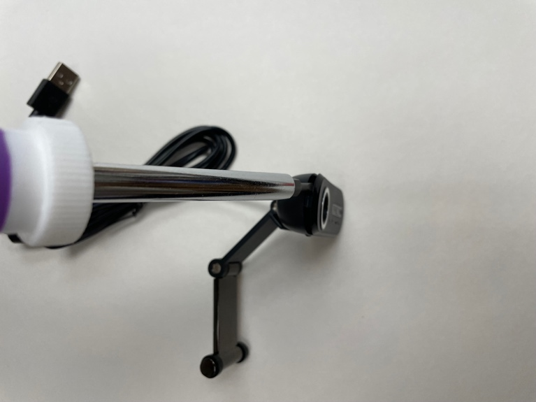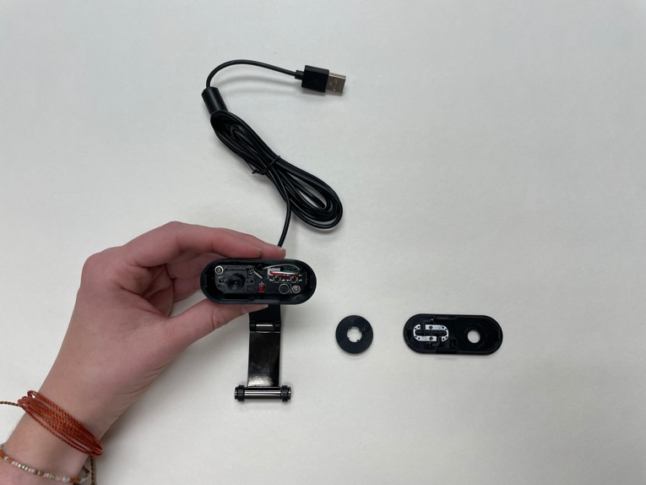

The part we are interested in is still hidden under the lens in the main compartment of the camera indicated by the red circle below:

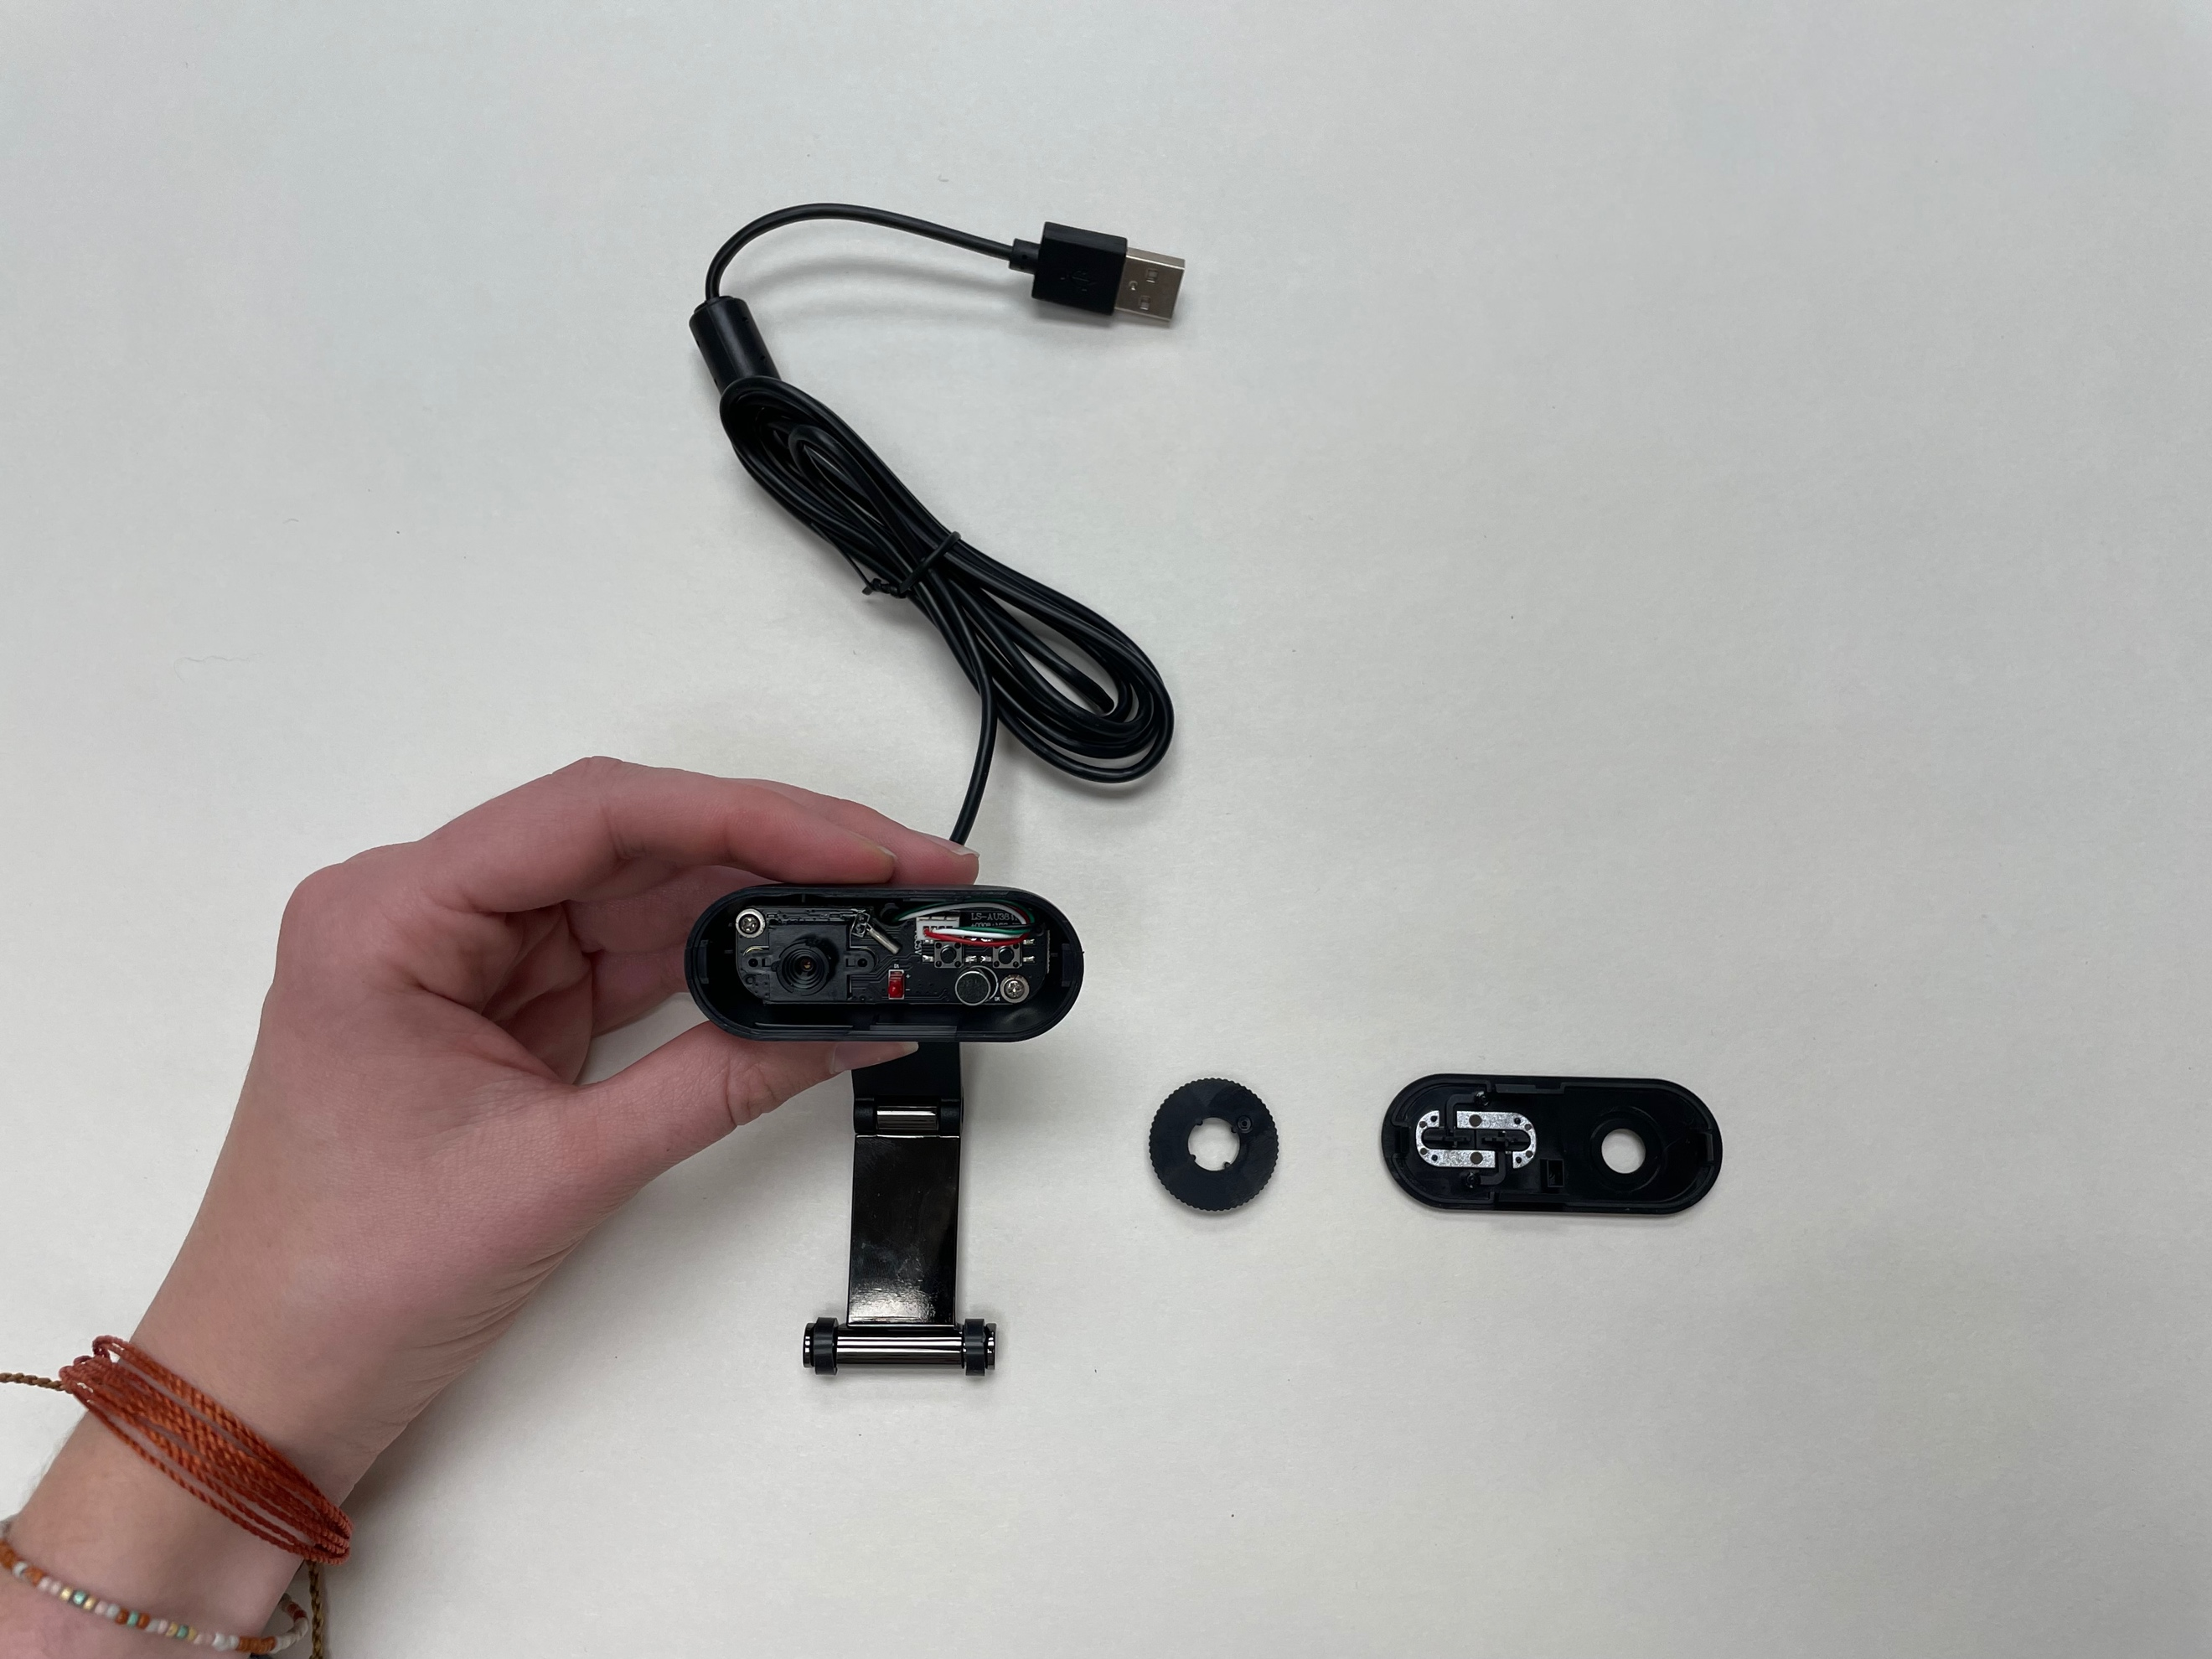

I removed the camera arm to make the camera itself easier to manipulate. I simply used a small Philips screwdriver to unscrew the pin that connected the arm to the body of the camera. You can see what it looks like here:

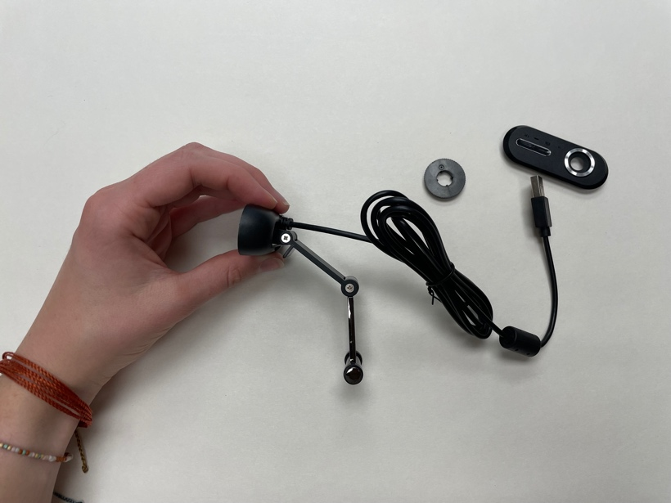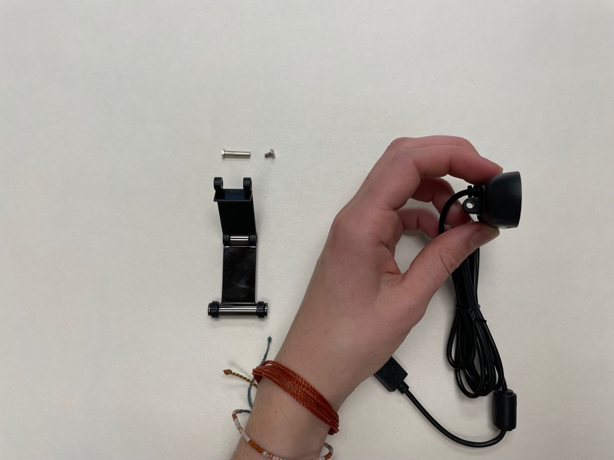

Now, I still need to remove the lense from the camera, so I can access the light sensor (our ultimate goal. The lense was really easy to remove, I just screwed it off. Here is the end result:

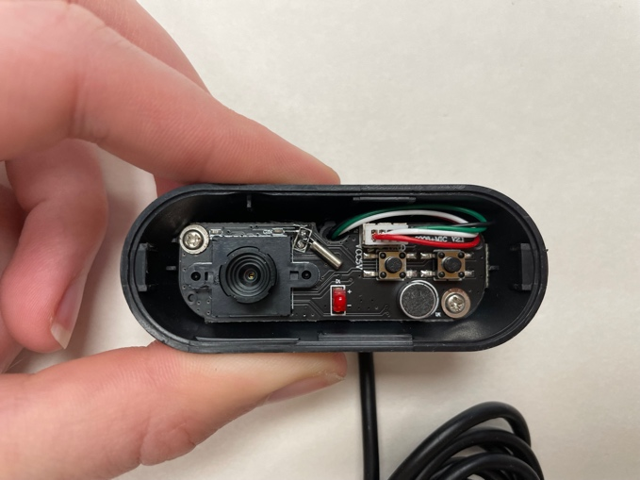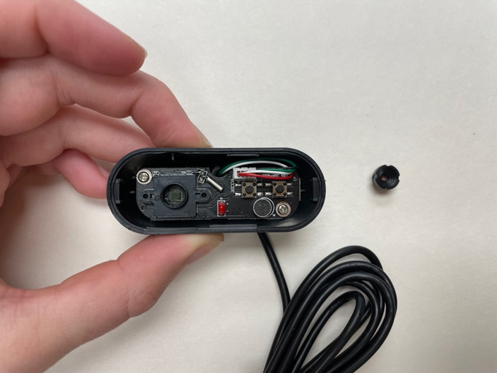

You can start to see the sensor there (indicated in the red circle)!

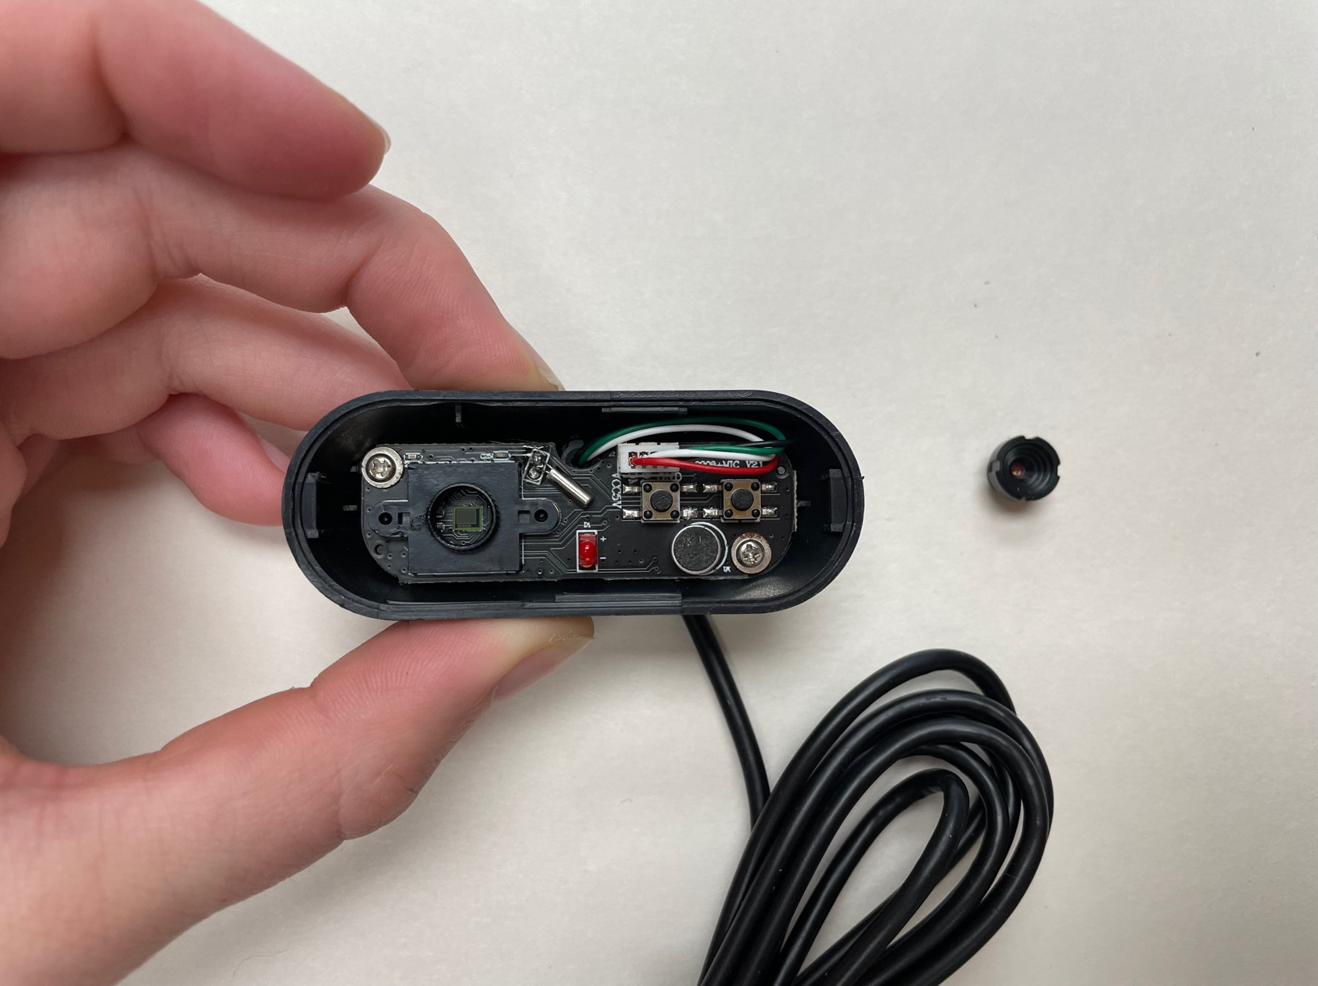

Now, at this point I felt it would be best to remove the “guts” of the camera, so I could find the easiest way to access the light sensor. I unscrewed the two small screws indicated below.



This is the end result:

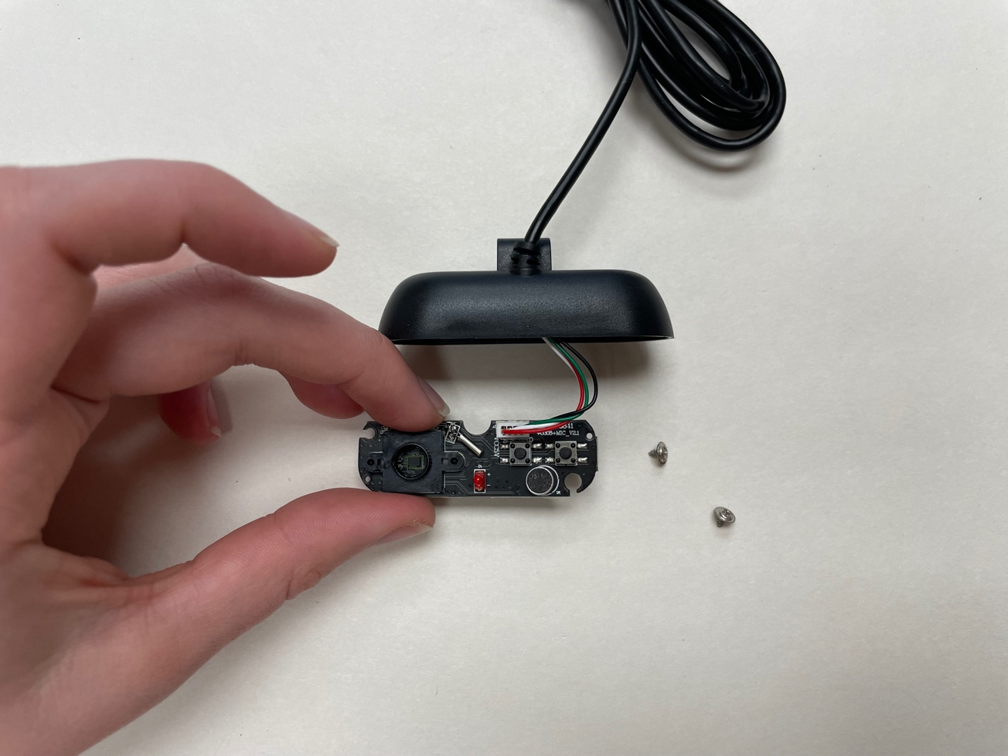

I want to be able to access the sensor more easily, so I need to remove the black shelf surrounding it. I flipped over the board and unscrewed the black shelf it from the back. You can see these steps below, the screws are indicated on the back of the board by red circles:

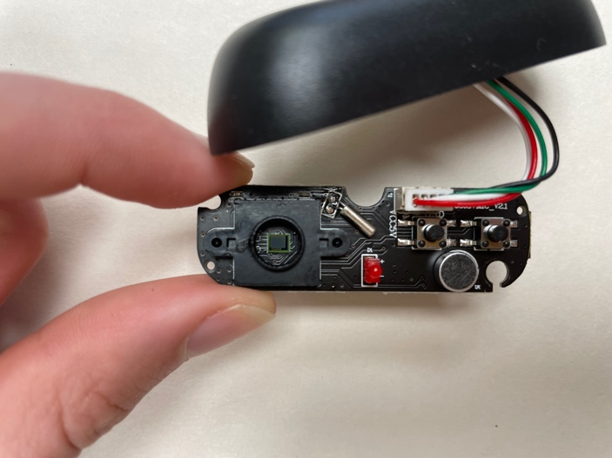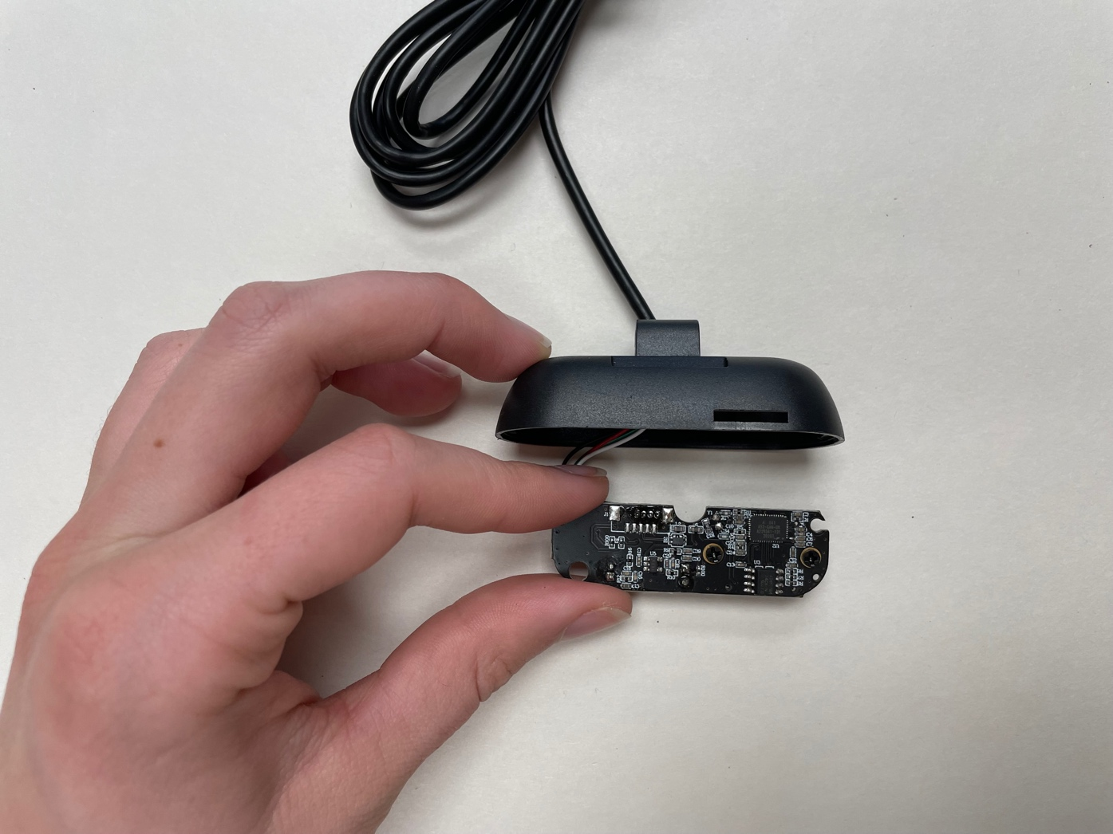

BACK

FRONT

And here is the end result:

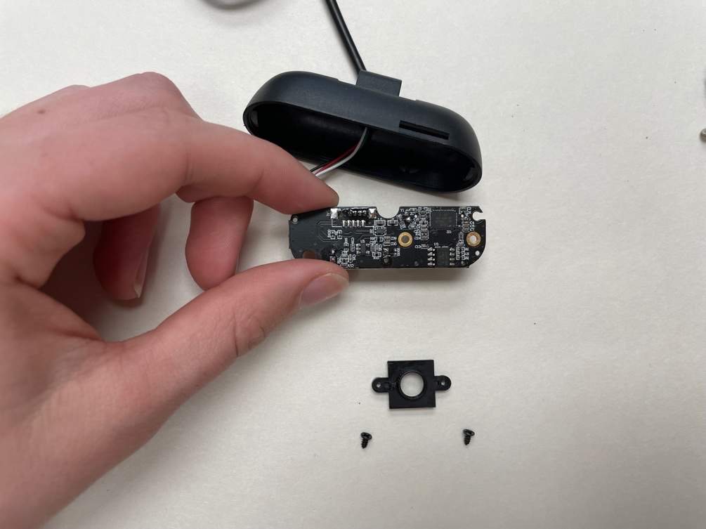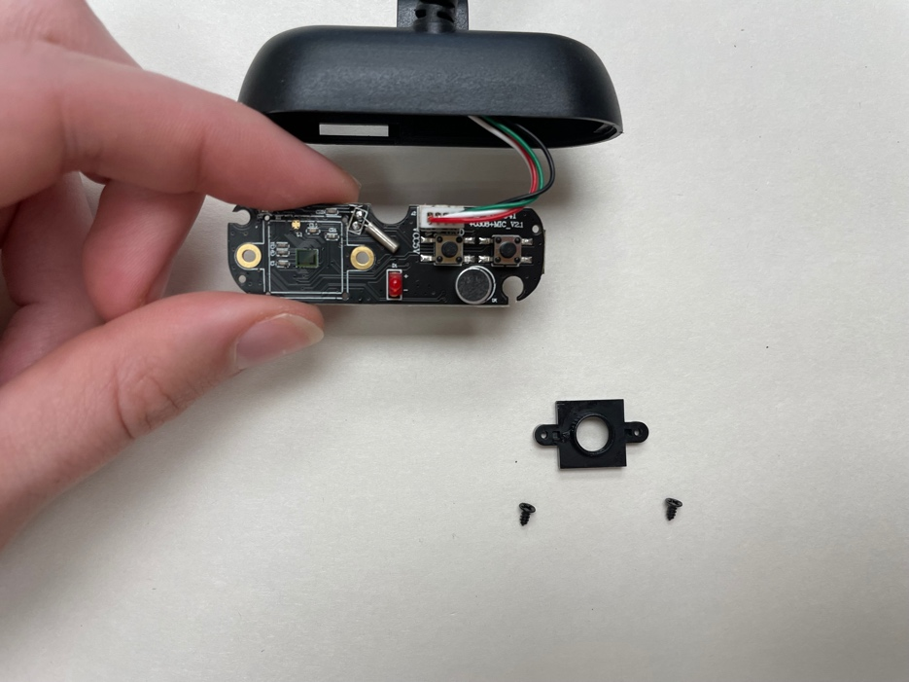

FRONT

BACK

At this point, I want to dislodge the wires from the hole they are in, so I can move the whole camera more freely and eventually remove it from the casing. This required a 90 degree turn to align the tabs on the wire holder with the cutouts on the camera case. See below:

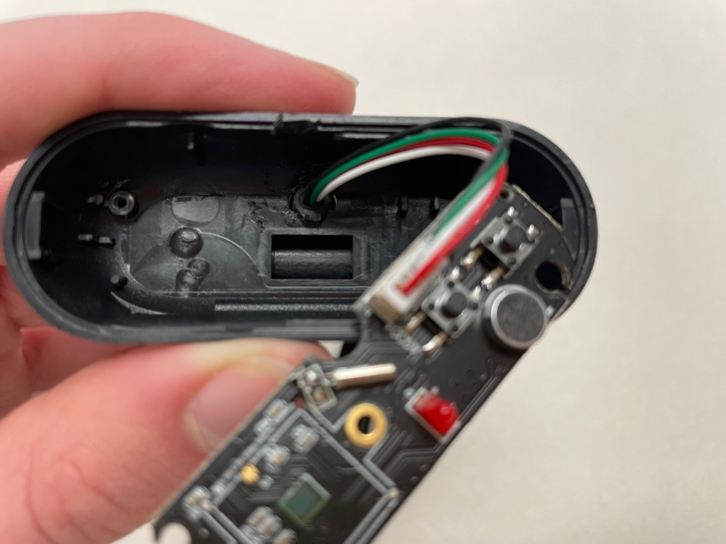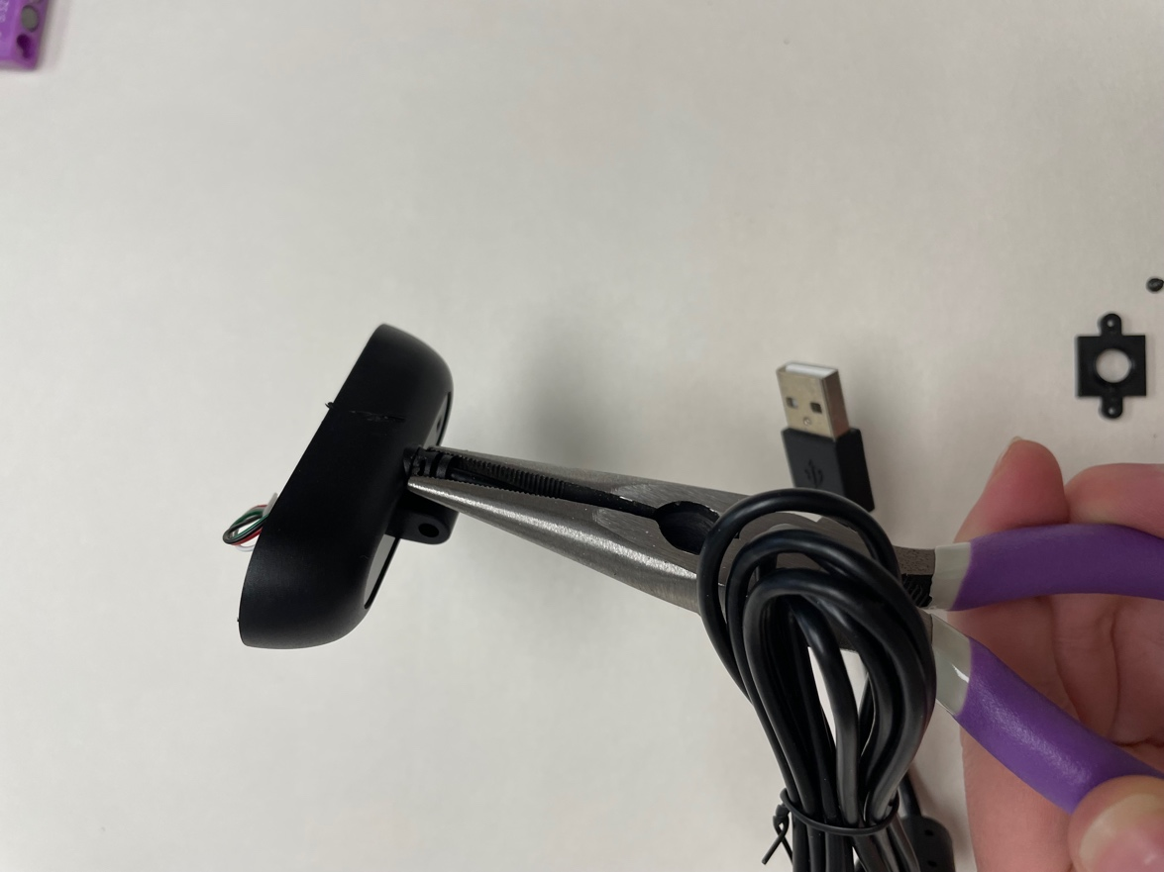

Now that is loose, I am going to disconnect the wire from the board like so:

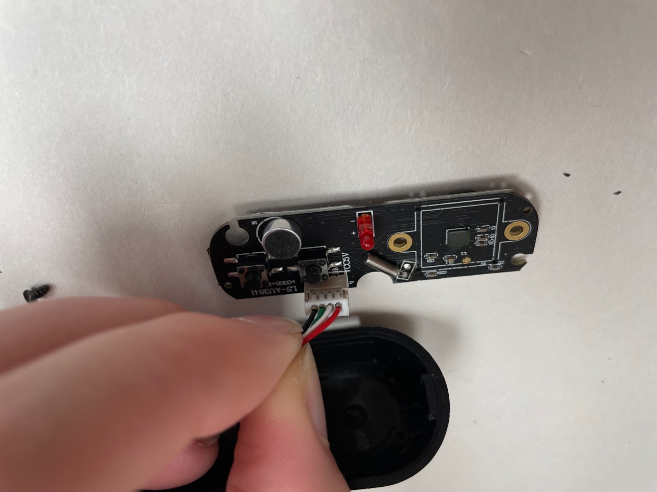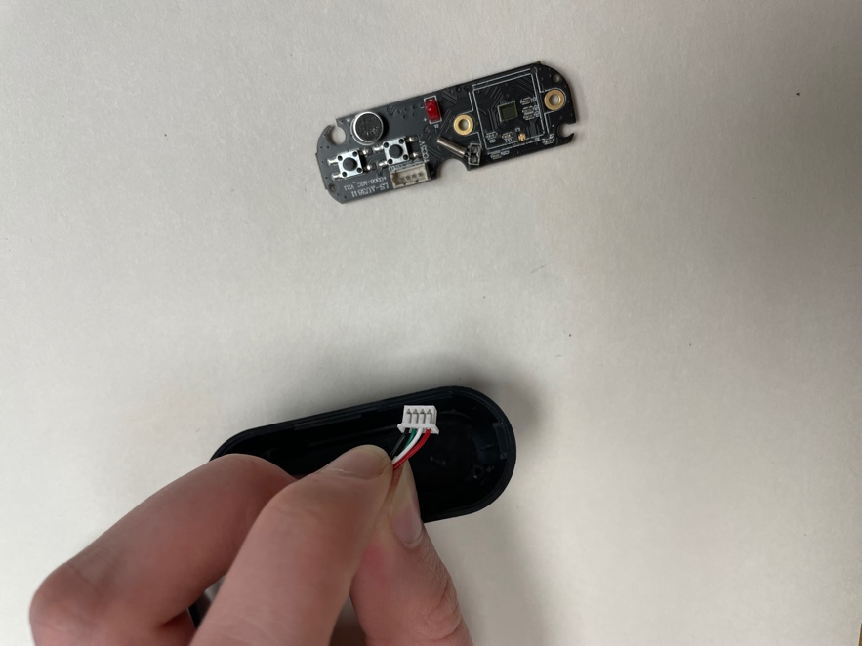

And then I am going to slide the wire through the hole to separate it from the casing:

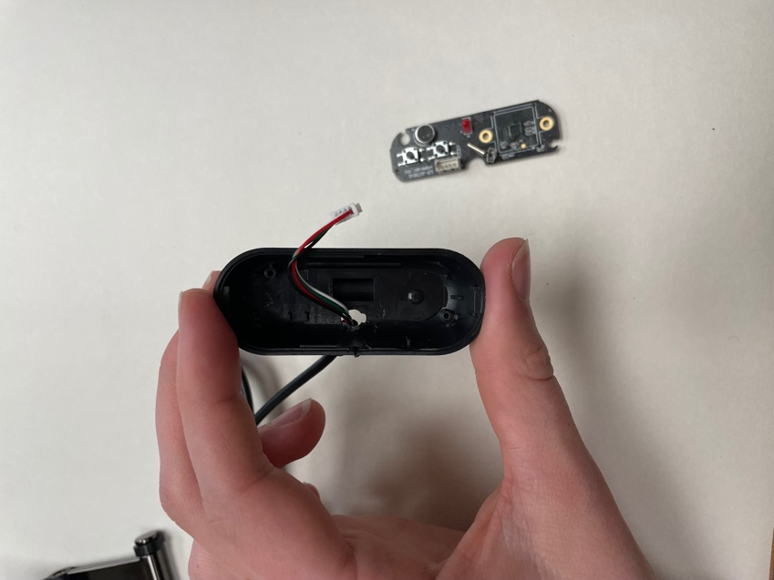

This is the end result:

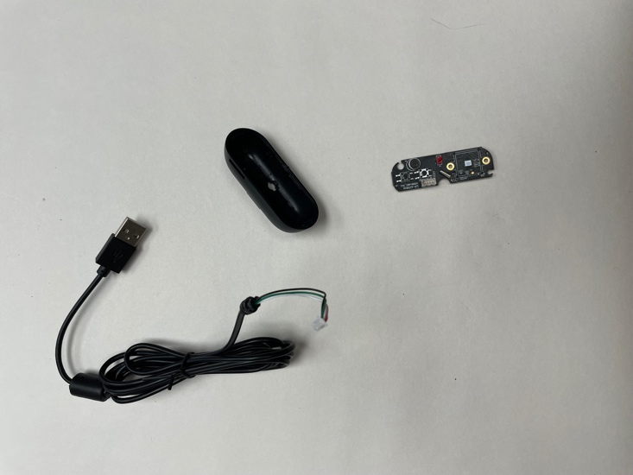

Now I want to re-connect the cord to the board. The four pins should align with the four holes and the cord should face how it does in the photo below:

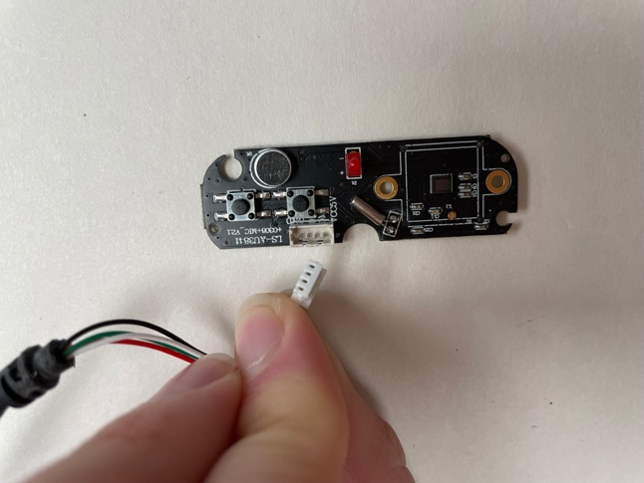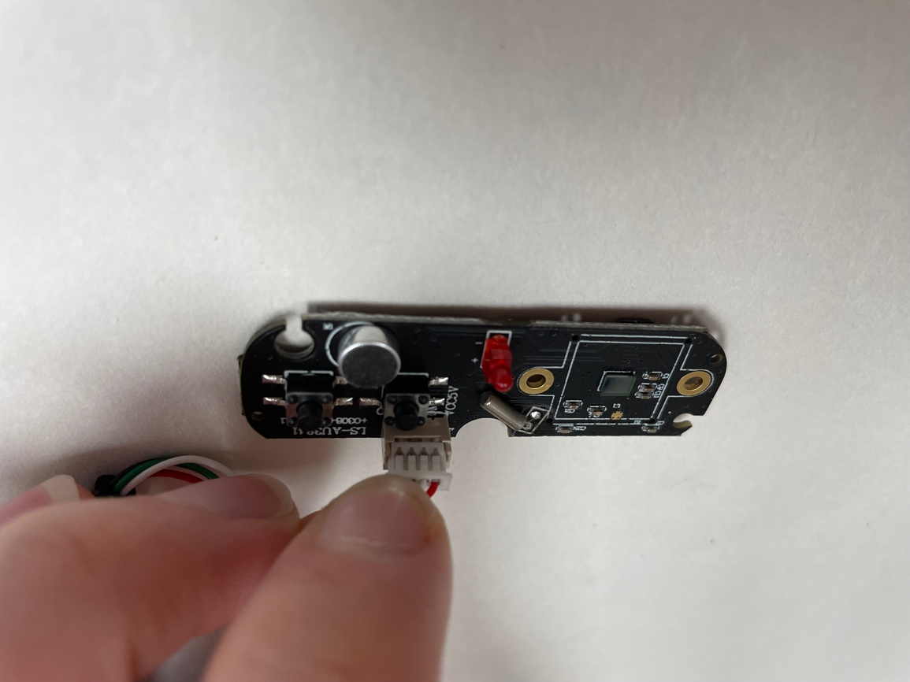

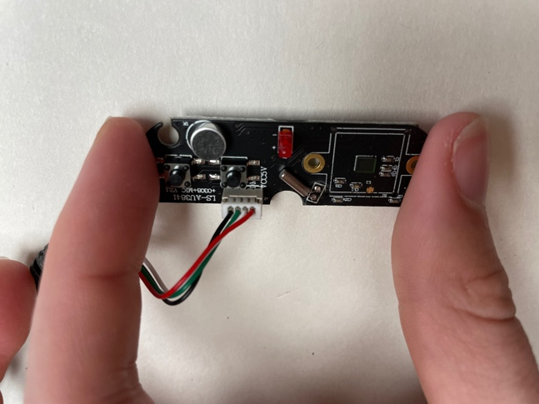

Now we have a fully connected and free camera apparatus!

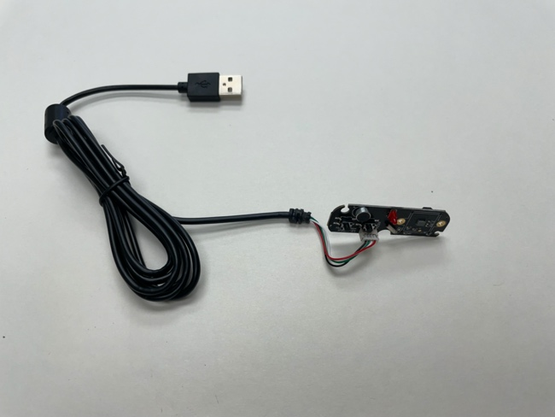

Now, we can work on waterproofing the board around our light sensor, so we can put samples on top of the sensor without worrying about causing damage to the rest of the camera parts!

First, I created a small, sensor-sized piece of tape with a tab on the end, so that I could prevent any silicone from getting on the light sensor, and I could easily remove it after the silicone dried.

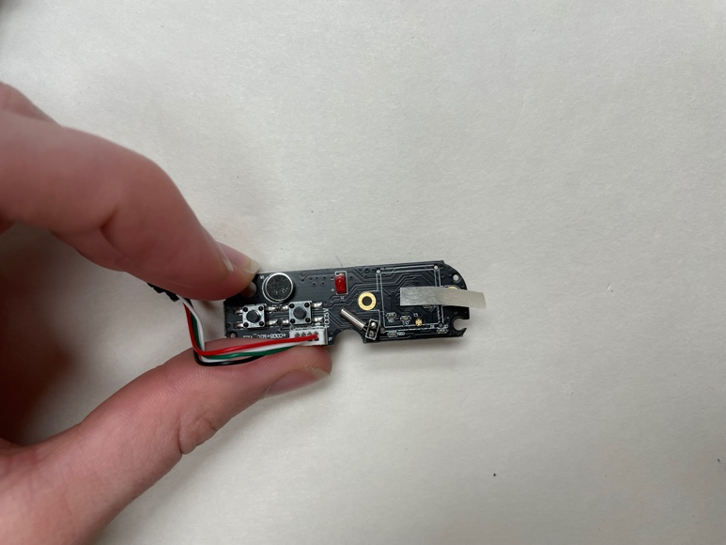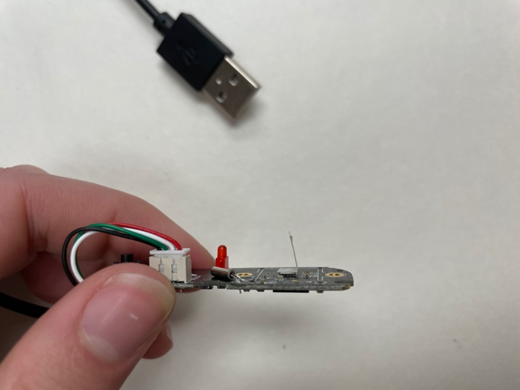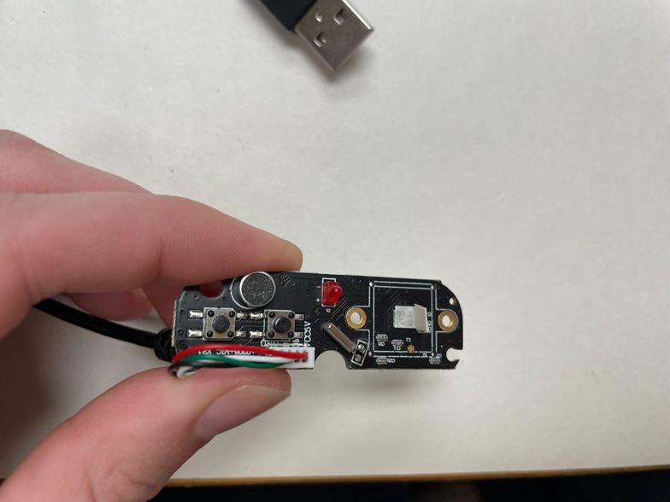

Next I carefully put silicone all around the light sensor to protect the board from any possible water damage. First, I used scissors to cut the top off the silicone and allow me to dispense it:

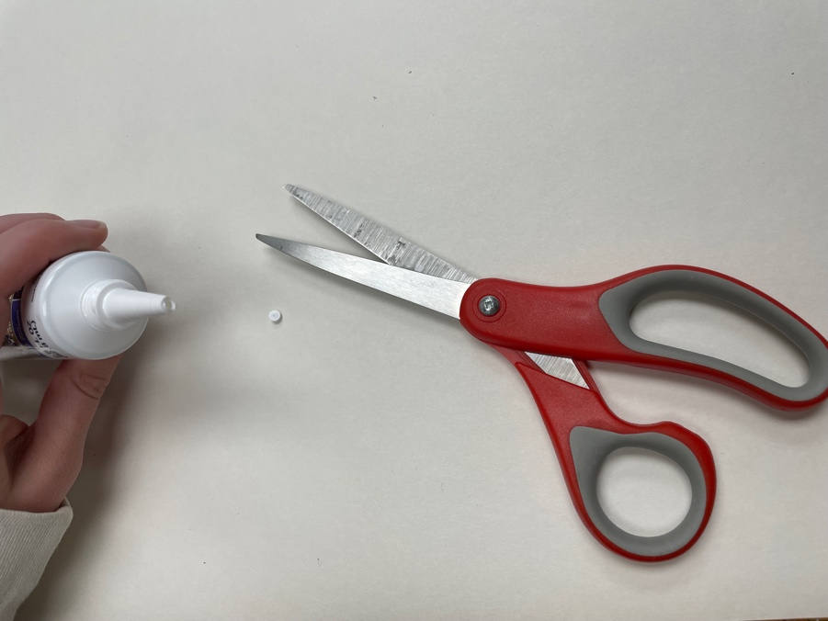

Then, I carefully spread the silicone onto the area surrounding the sensor, starting from the center and then moving out:

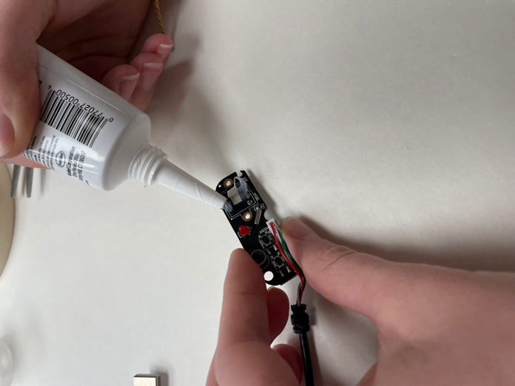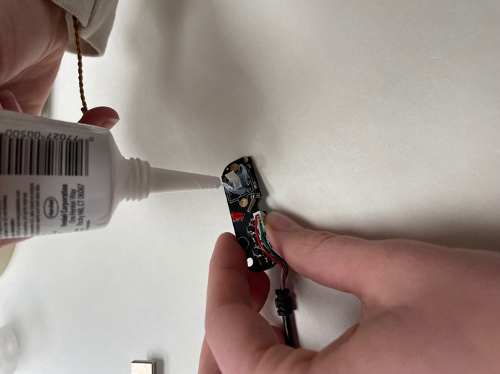

I used the thumb tack to help me spread and smooth the silicone, making sure it was sealed tightly against the side edges of the sensor, so there were no gaps.

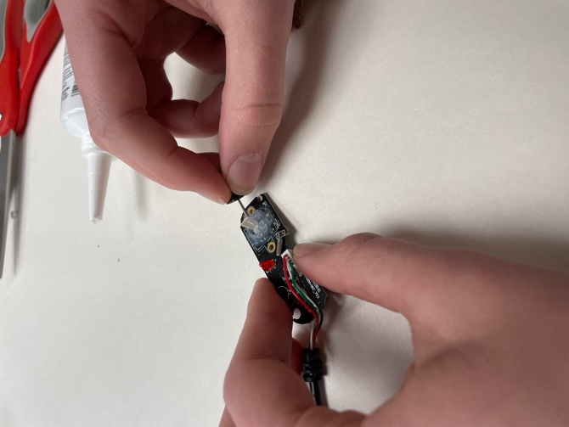

Once you’ve successfully surrounded the sensor, carefully remove the tape you used to protect it. Look closely and use the thumb tack again to spread the silicone into the edges to make sure there is a complete seal between the edge of the sensor:

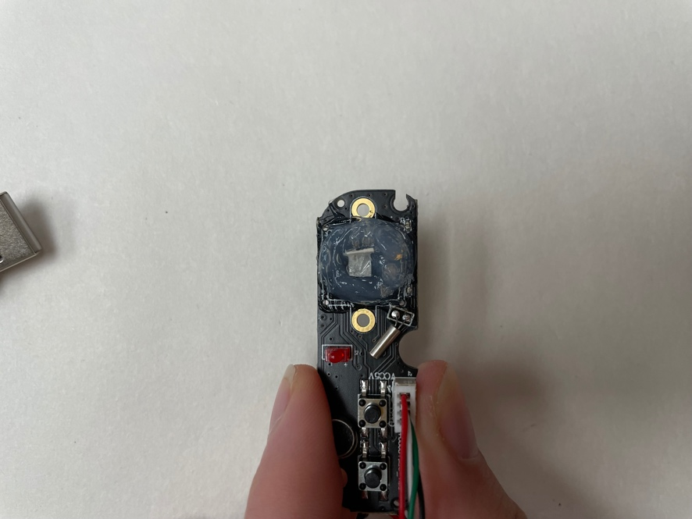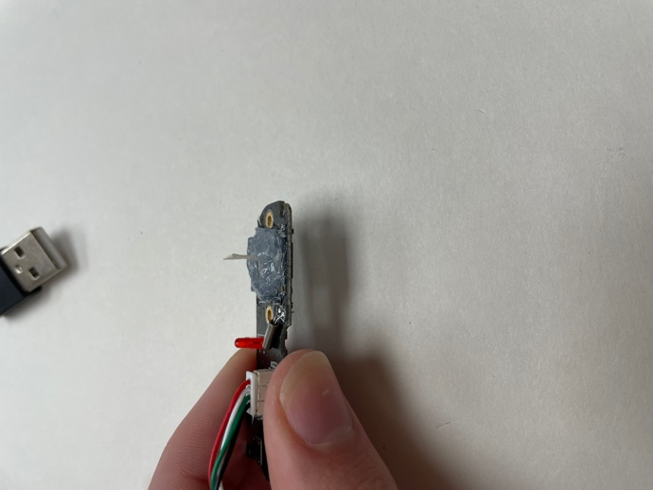

Make sure there are no gaps after you remove the tape!

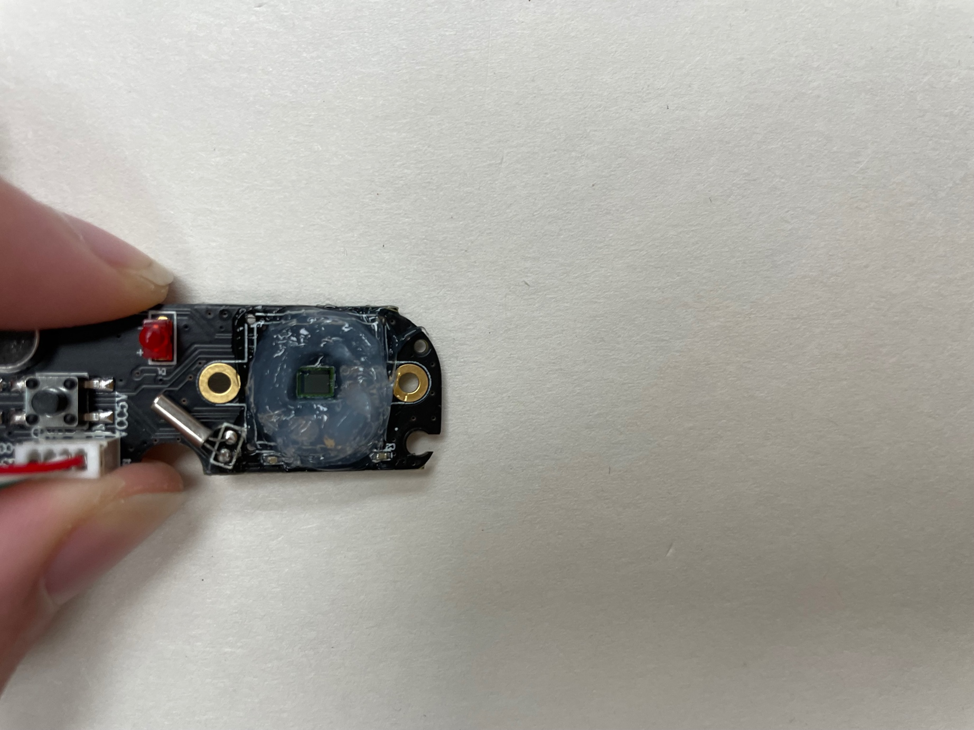

Now, let the silicone dry. This one says to wait 24 hours before exposing it to water!

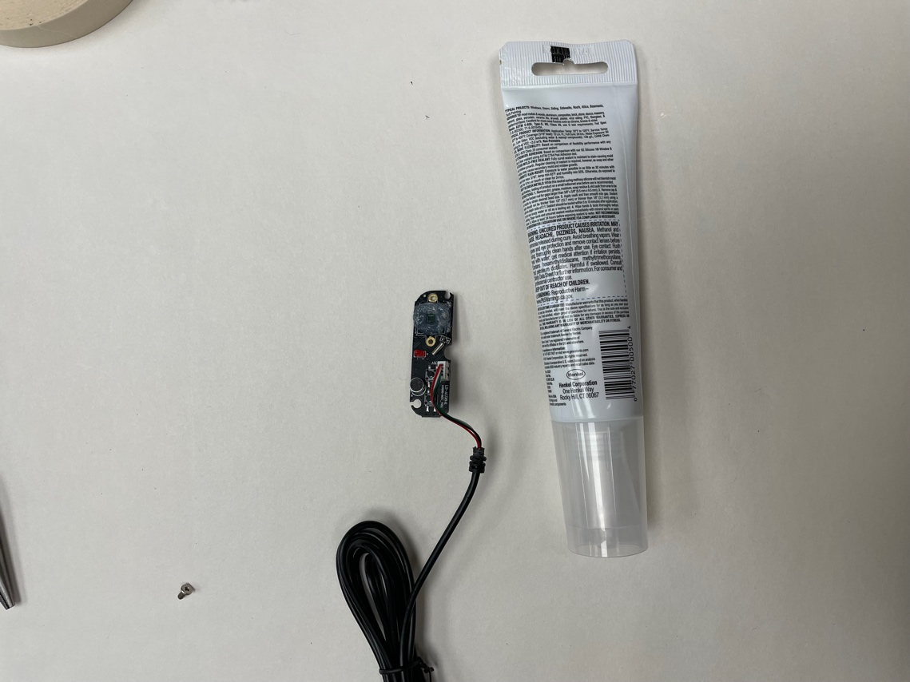

24 hours later-- we can complete the scope! Let’s start by putting a pinhole in the top of the tube. Set aside the bottom of the tube which we took off the can to make the limeade- we will use this later. Grab the tube, which should have the top still attached, this is where we want to put the pinhole. I want it to align perfectly with the light sensor, so we will use it as a template:

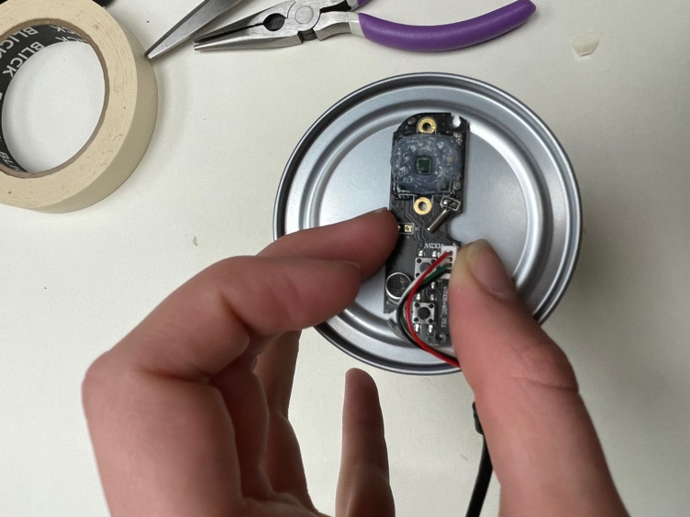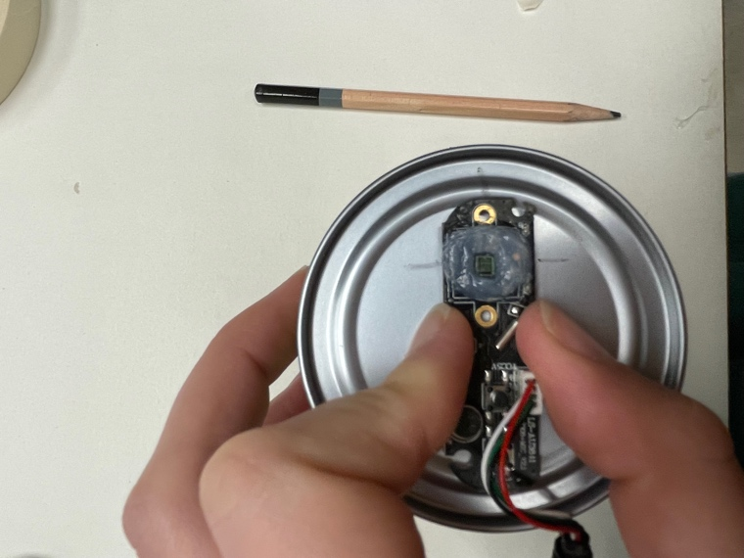

I placed the camera on the top of the tube, then used a pencil to mark the center of the sensor on the top and sides. Then, I connected those lines to create a cross where the center of the sensor is:

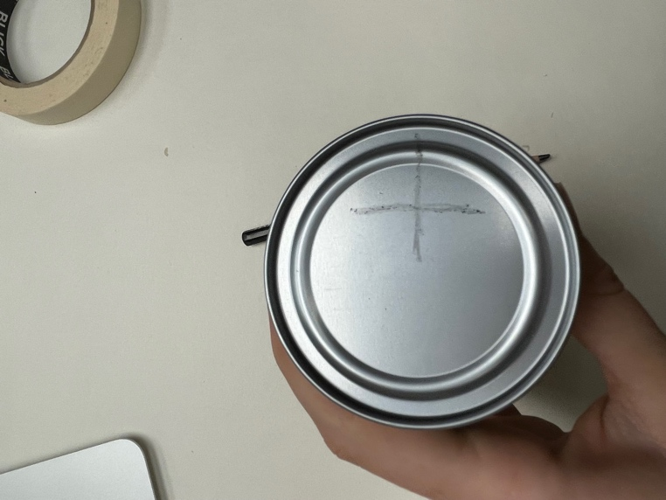

After I drew the cross, I then used the thumbtack to CAREFULLY poke a hole in the center of the cross. CAUTION here! Press firmly with the thumb tack, I found that turning it slightly as I pressed helped the tack puncture the aluminum top more easily:

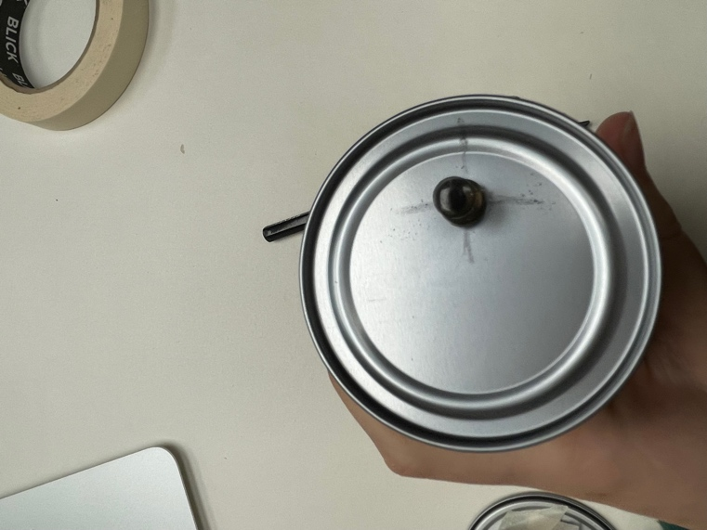

Great! Now we are ready to test out the camera and make sure it is working… I plugged the USB into my computer and noticed something that needed to be fixed:

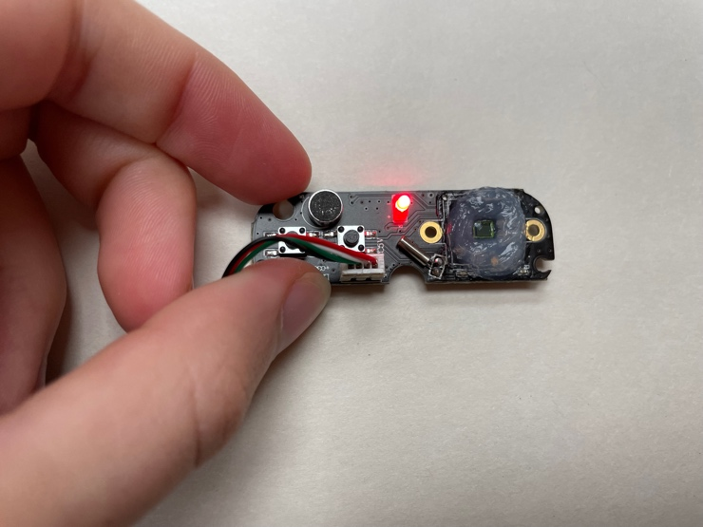

That little red LED was going to create a problem! So I simply used plies to twist it off… unplug the camera first though!

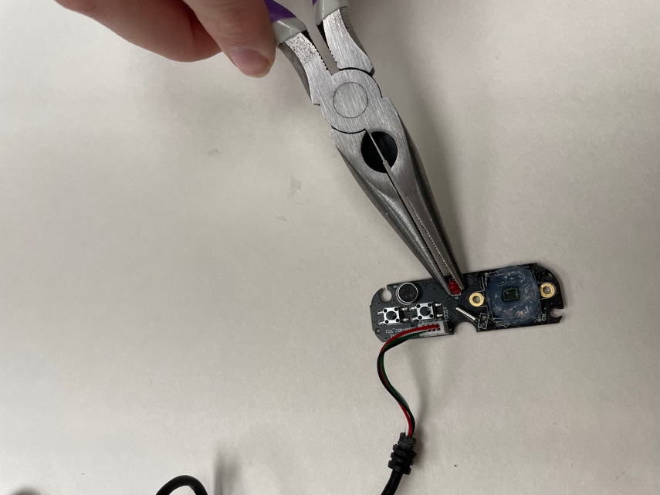

Great! With that removed, we should be good to go. I am going to tape the camera to the base plate of the tube like so:

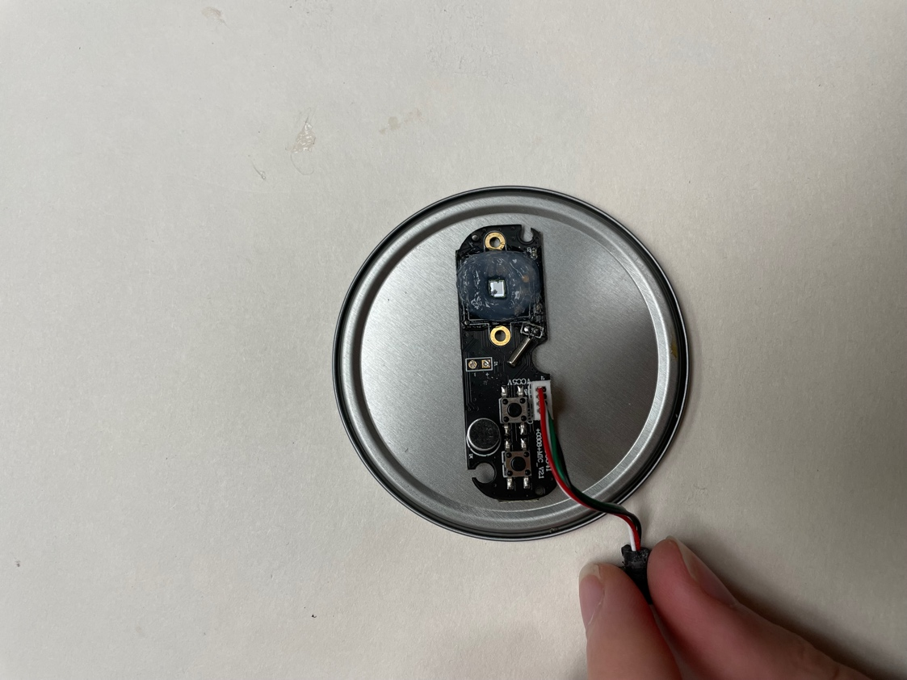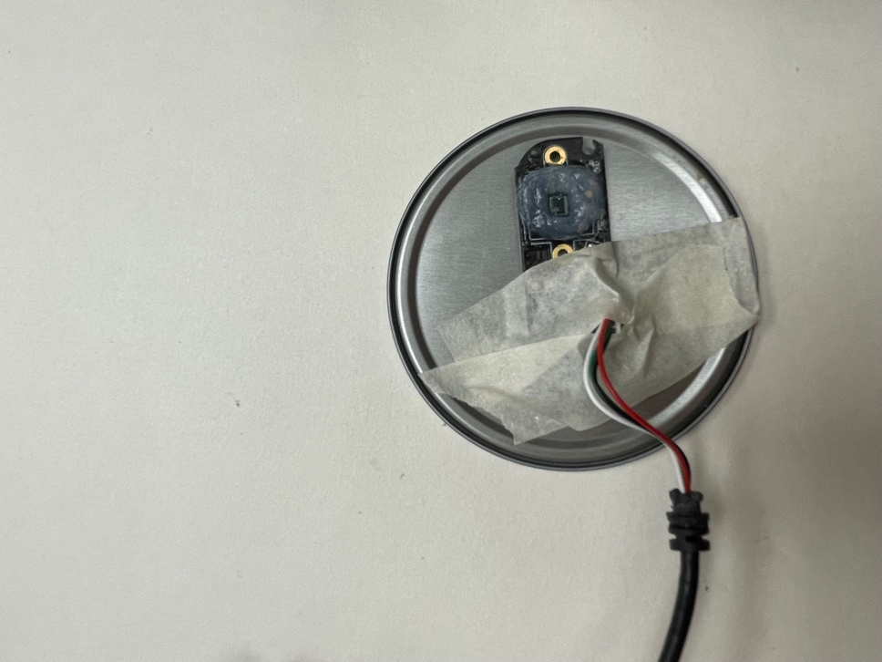

This will help prevent the camera from moving around a bunch when we put the tube on top! Now, we can test the tube. Align the pinhole with the sensor, and place the tube on top:

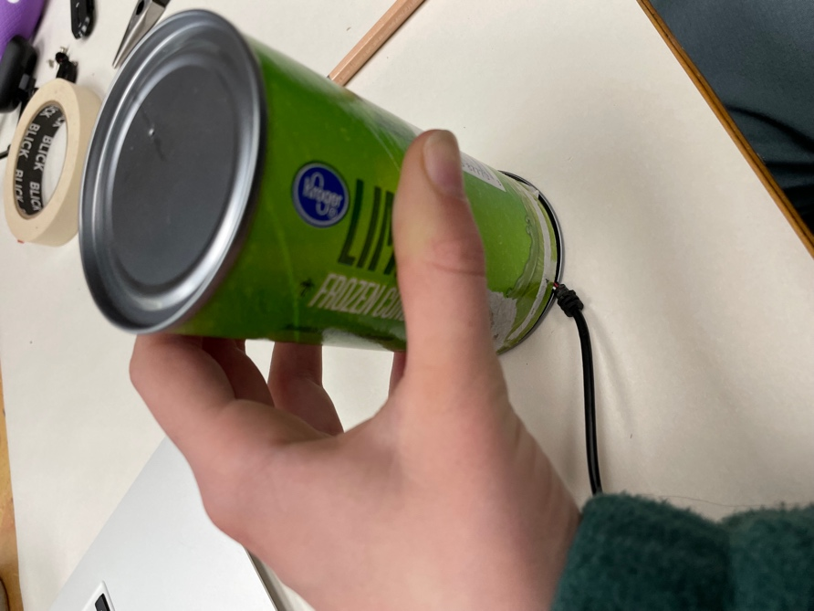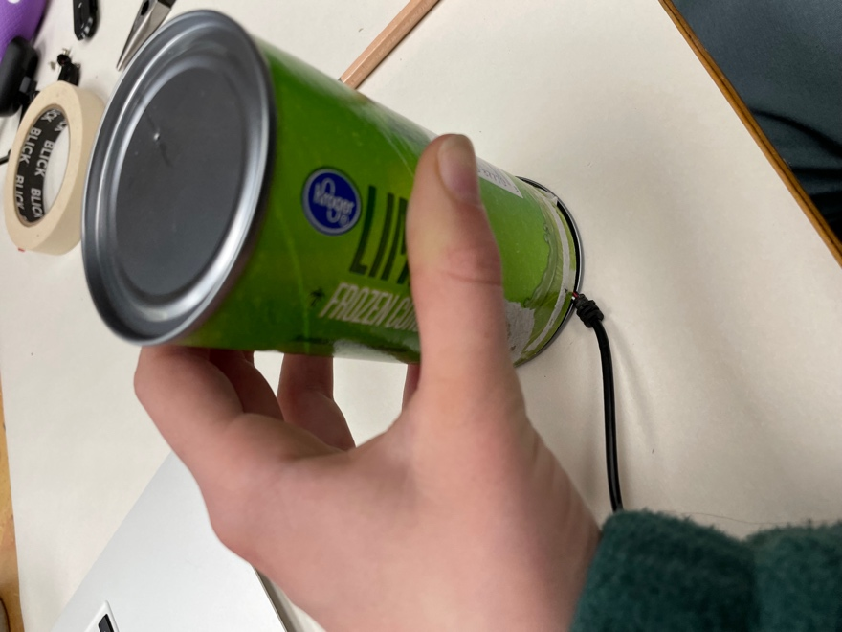

You will want to make a very small notch where the cord comes out, so the tube can close and seal properly:

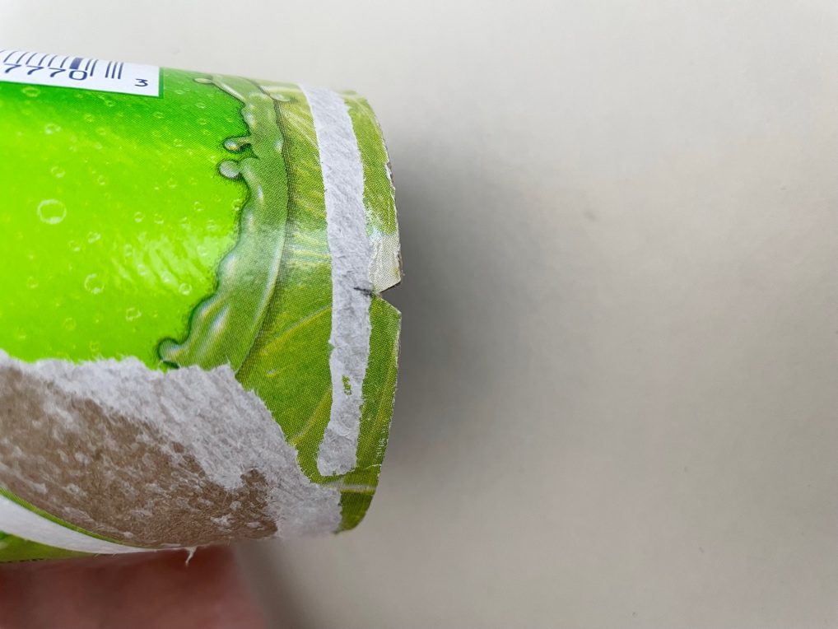

After you’ve made that notch, I recommend reinforcing the bottom edge with a piece of packing tape, so that the cardboard doesn’t get frayed with use:

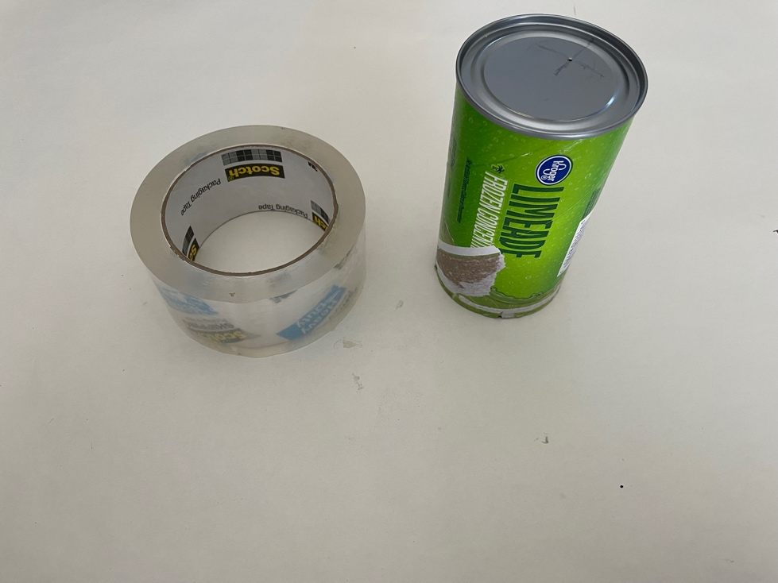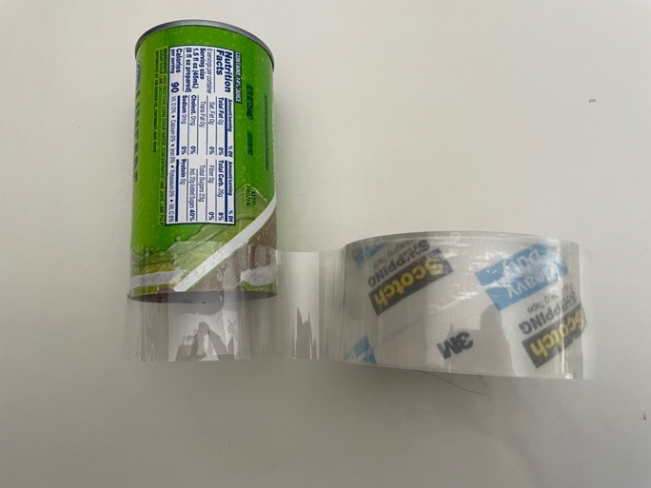

Now, cut and fodl the tape inside the tube:

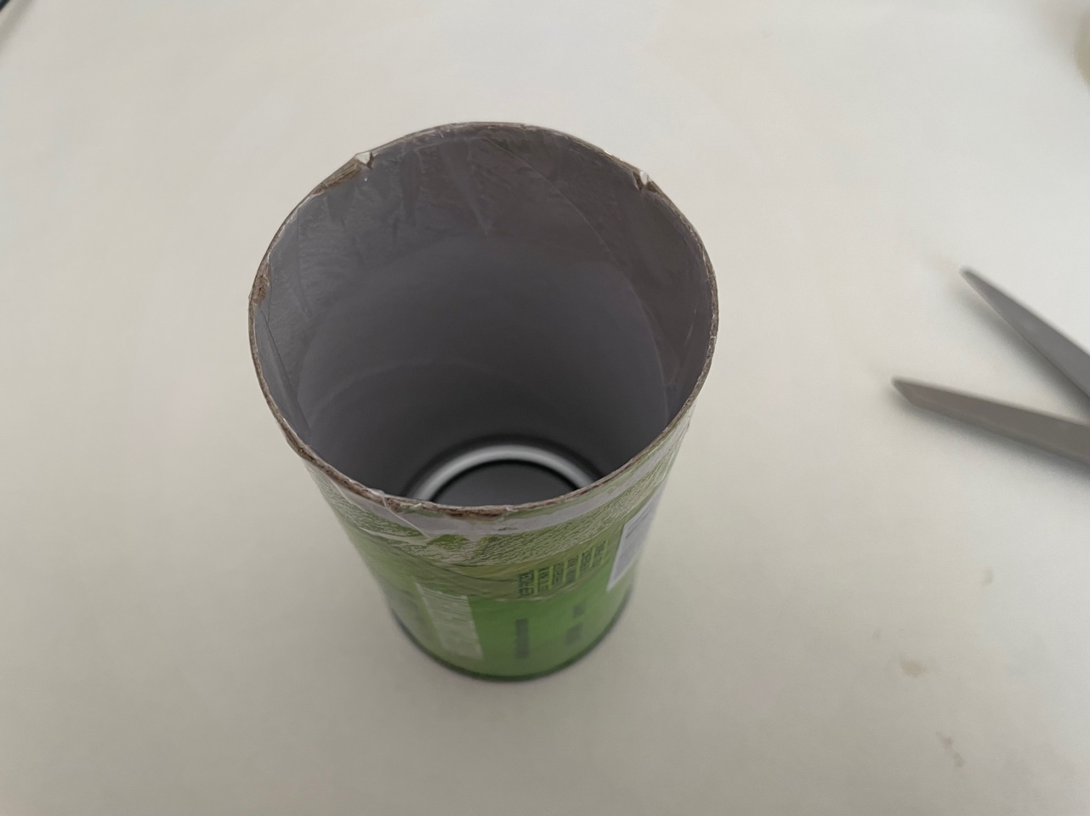

Then, trim the tape to accommodate the notch we made before:

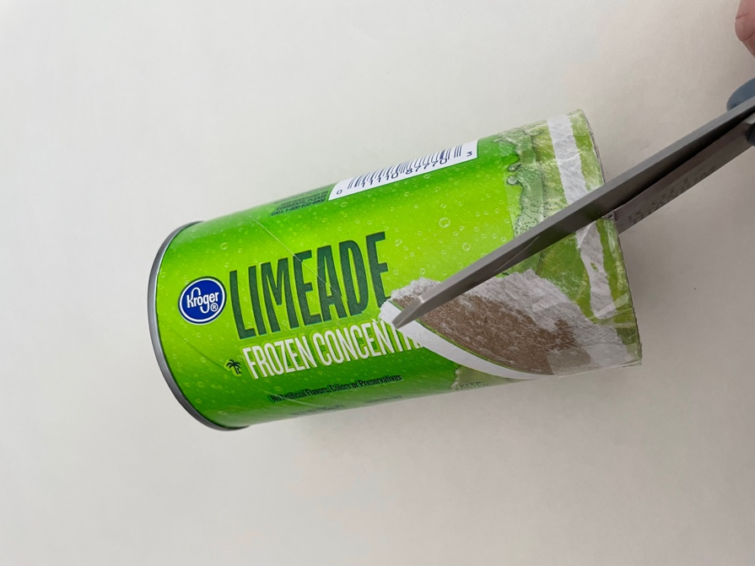

Great! Now, you can attach the tube to the bottom piece to enclose the camera:

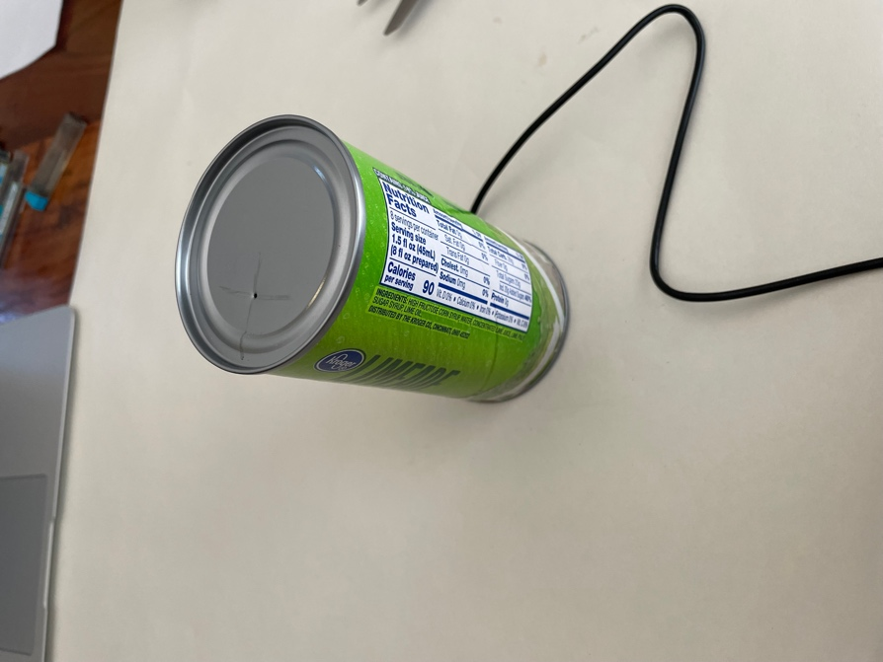

At this point, you can plug in the shadow scope to a computer and use the native video recording software. I have a mac, so I use QuickTime, which I open up and select “Record new movie.” Remember, you might have to switch your settings from using the laptop camera to the external camera. Right now, you will probably see a dark colored or even black screen. That’s because there is no light!

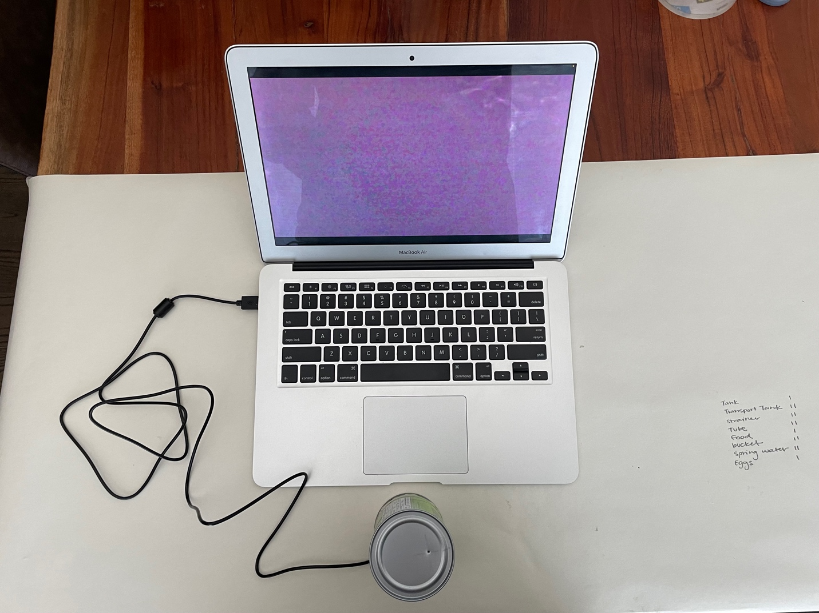

Turn on the flashlight and put it directly on top of the pinhole:

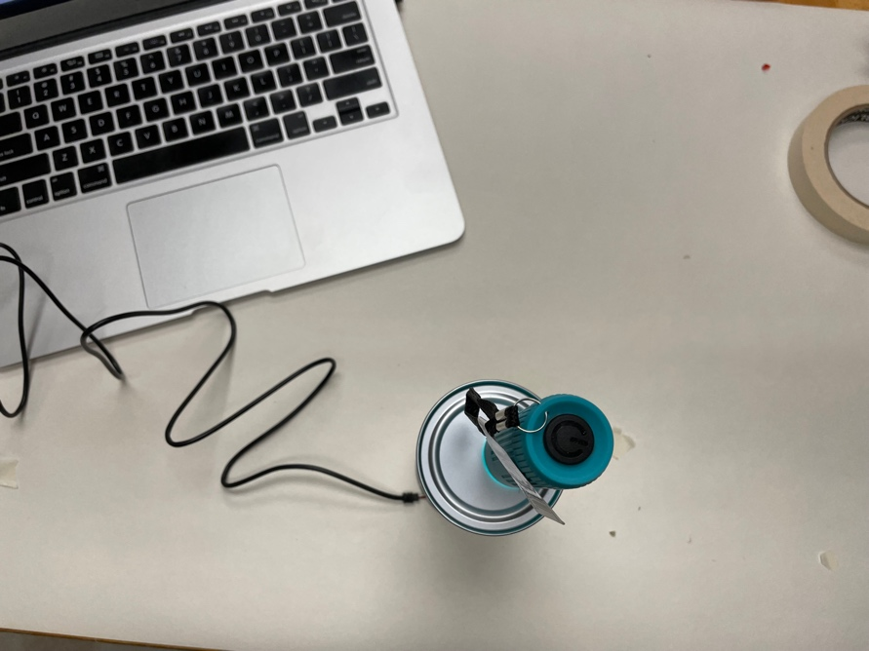

And now you have a fully set-up shadow scope!!! Congrats!!!

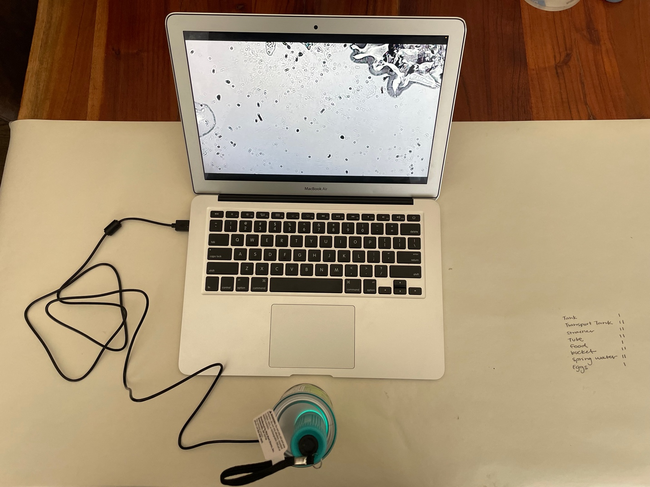

Now we can start looking at samples! See the next post to learn how to view samples in your Shadow Scope!